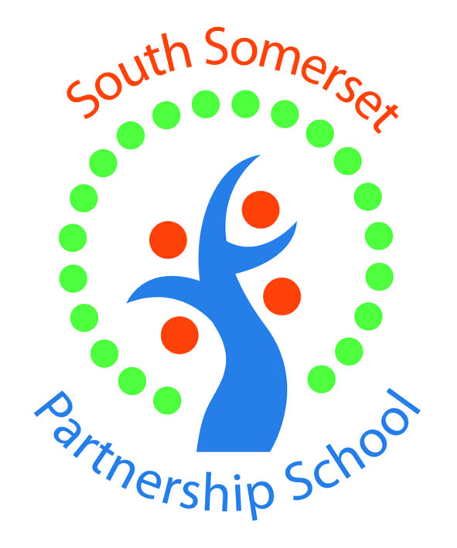

South Somerset Partnership School (PRU) requires:

Administration Support Assistant (Grade 15)

Start Date: Sept 2024

Part time fixed term contract of 1 Year initially. 20 hours a week, term time only – hours to be negotiated, mainly based at our Dampier Street site however some travel to other sites may be required.

We are looking to appoint a highly organised, enthusiastic and efficient administration assistant to support the day-to-day running of the school and be pro-active in organising and maintaining effective administration systems.

The successful candidate will possess excellent interpersonal and communication skills, be capable of prioritising and handling varied workloads, have a positive and professional manner and above all be able to adapt to the role to meet the changing needs of the school.

Experience in a school would be an advantage but is not essential as training will be provided.

The post requires a criminal background check via the Disclosure procedure.

For an initial discussion, once you have received the job details, please contact Claire Brand, Business Manager, tel: 01935 410793

Please apply online at www.somerset.gov.uk/jobs. Please email completed application forms to Claire.brand@ssps.org.uk

Closing date: Noon 22nd July 2024
Interview date: tbc but likely 25th or 26th July 2024

